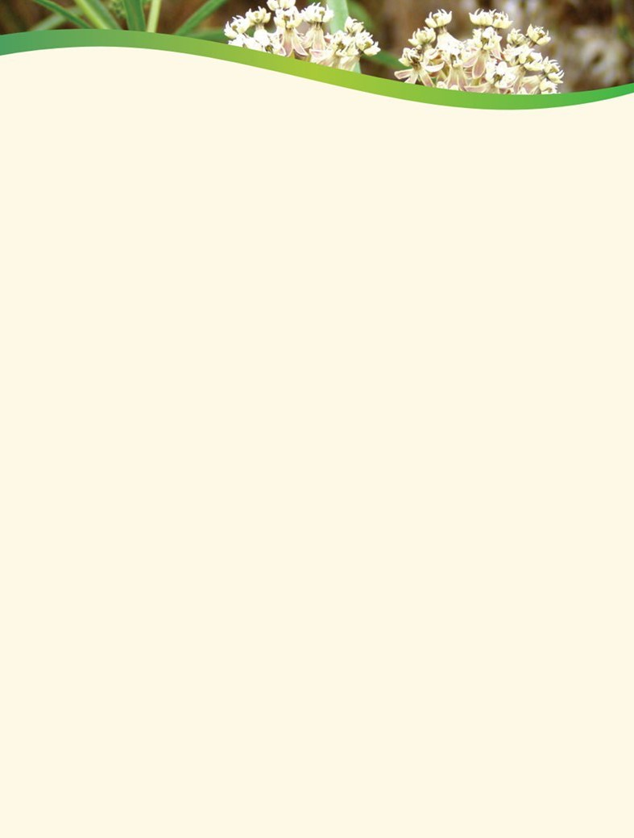

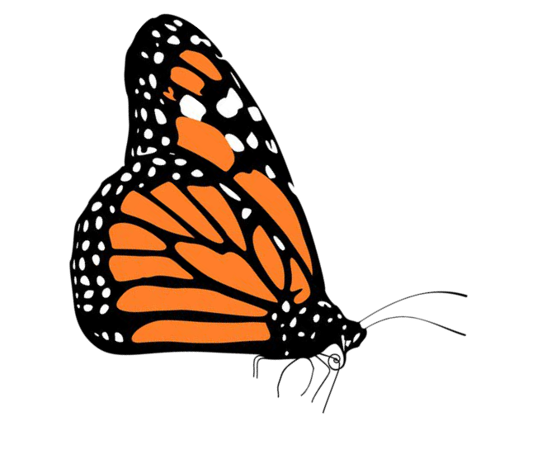**1, 2, 3...for the Butterflies and Bees Program Application**

Thank you for considering the Riverside-Corona Resource Conservation District's 1, 2, 3...for the Butterflies and Bees pollinator habitat kit program. Any resident or community entity such as a library, school, community garden, farm, business, community center, etc., located within the [RCRCD district boundary](https://www.rcrcd.org/district-boundary-map), is welcome to apply for a **free** kit. Approximately 50-60 kits will be available each year and priority will be given to those individuals or entities located in an underserved community. Two to four different kits will be available to choose from year to year and plant species will vary depending on plant availability. Each kit will cover approximately 150-1000 square feet, depending on kit type and planting layout. Those that apply but do not receive a kit due to availability, will be placed on a waiting list and receive priority for the following year. One kit per applicant. Applicants who receive a kit are not eligible to reapply.

Please answer the questions below. Completed applications and program questions should be emailed to Michele Felix-Derbarmdiker, at [Felix-Derbarmdiker@rcrcd.org.](mailto:Felix-Derbarmdiker@rcrcd.org)

Applicant Name:

Group or community entity:

Address (Where will the plants be planted?):

Email address:

Phone number:

How did you hear about our program?

Kit type (Plants in each kit are listed on the next page):

Provide a short description of where the kit will be planted:

Provide a short description of why you are interested in our program:

Are you currently experiencing transportation hardship, unable to drive or live in an area lacking public

transportation? If yes, would you like your kit(s) delivered to your home or planting site?

A plant information sheet will be included with your kit. Would you prefer the information sheet to be in Spanish or English?

Thank you for applying for the 1, 2, 3...for the Butterflies and Bees Program!

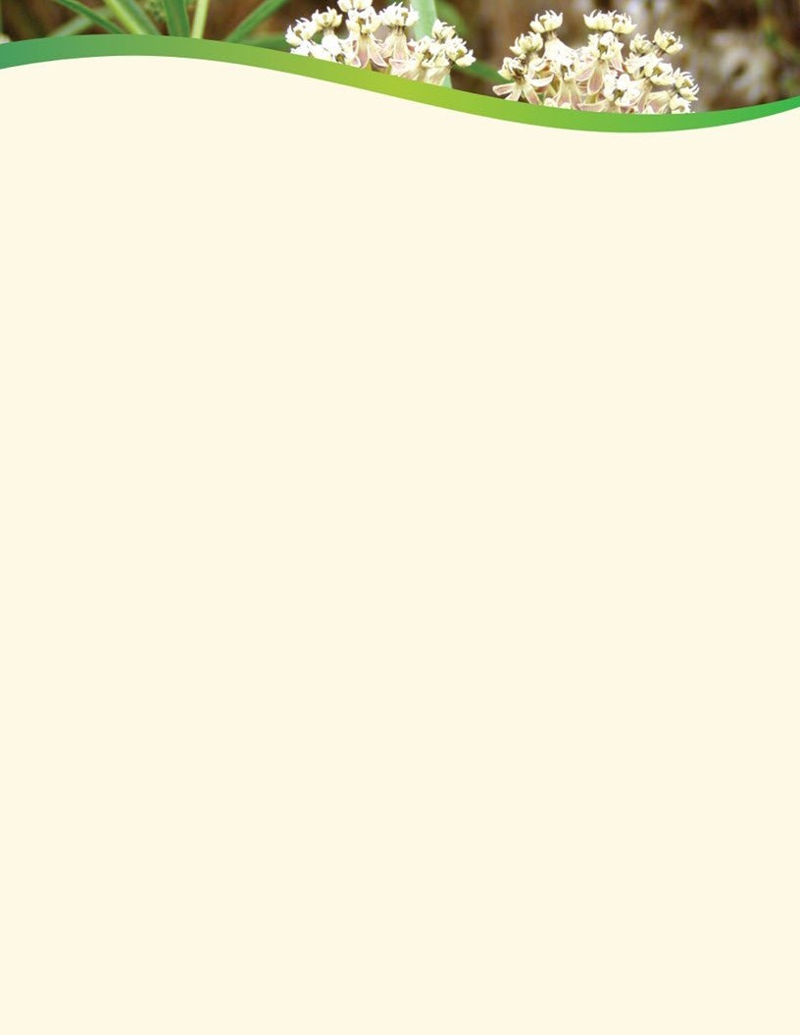

**202*5* Habitat Pollinator Kit Plant List**

 Mini kits cover approx. 150 sq. ft. and Full sized cover up to 1000 sq. ft. 

# Sun (Plants that tolerate 6+ hours of daily direct sunlight):

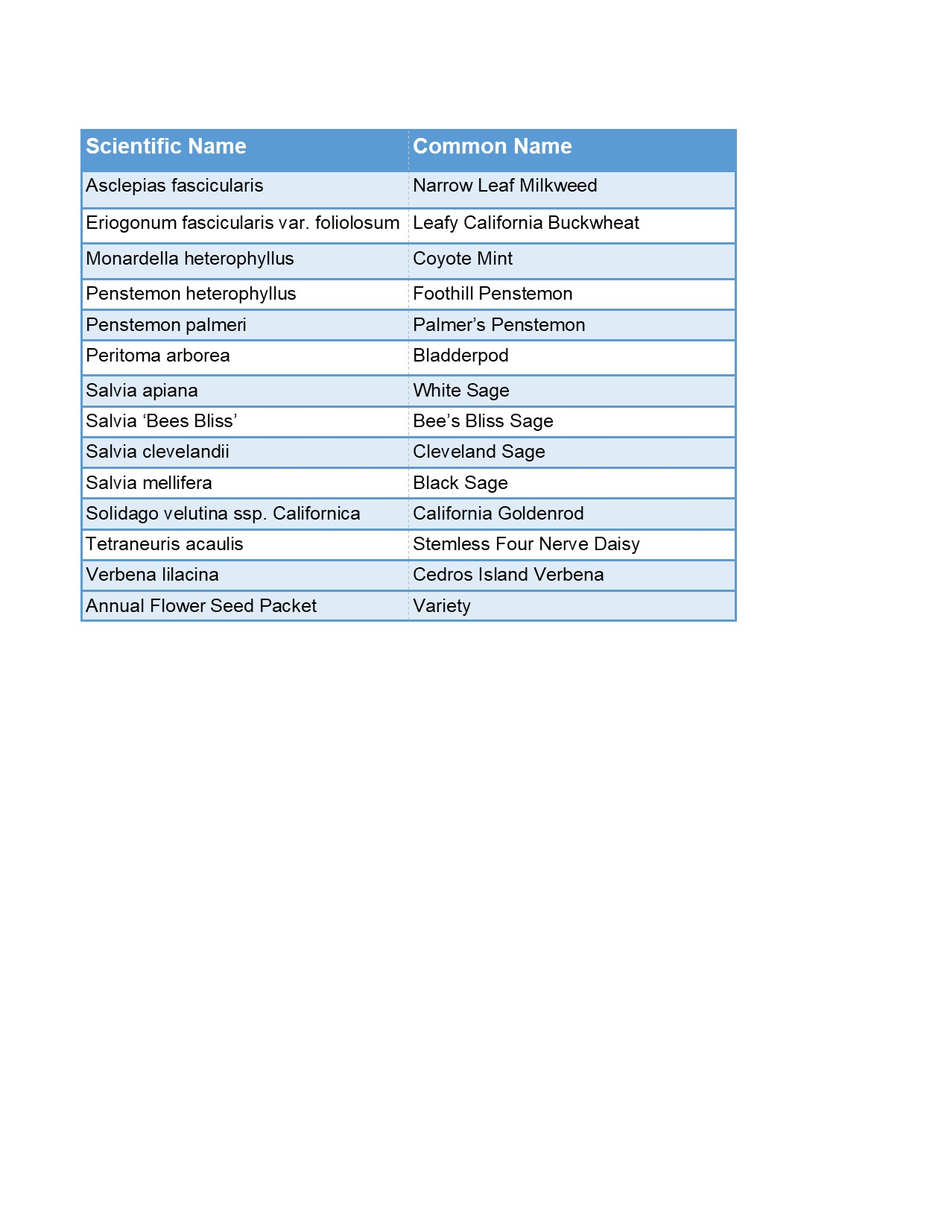

**Partial Shade: Hedgerow:**

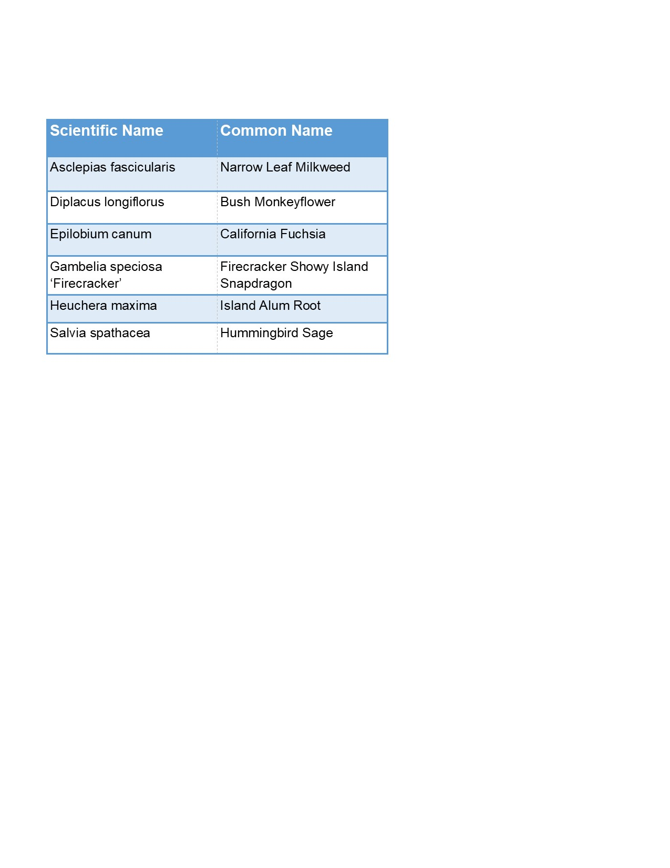 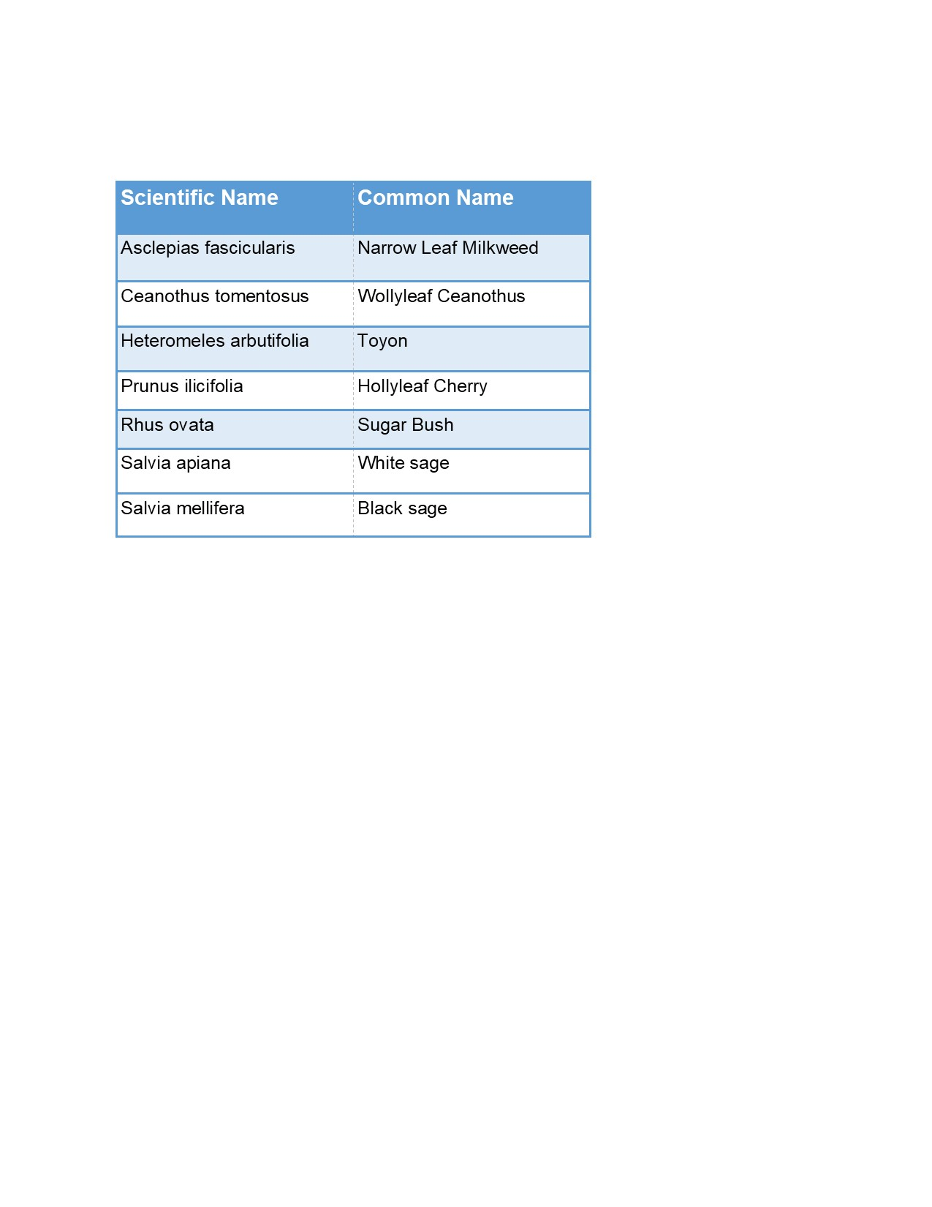

# Species will vary due to availability. In the name of sustainability, we kindly ask that when feasible, you return empty plant pots to our LandUse Learning Center (4500 Glenwood Dr Riverside, CA 92501). The center is open 7 days a week from 8a.m. to 4p.m. Closed holidays. These pots will be cleaned and reused.